**Master of TECHNOLOGY INTELLIGENT SYSTEMS (PART-TIME) 2020  
  
SEMESTER 2 – Pattern Recognition and Machine Learning Systems (PRMLS)  
Installation & User Guide**

**Driver Drowsiness Detection System**

# Steps to run the Project in Windows Environment v10:

1. Programs are developed in
   1. python version 3.7.7,
   2. matplotlib 3.1.3
   3. Computer Vision (Open CV) 4.4.0
   4. imutils 0.5.3
   5. dlib 19.21.0
   6. scipy 1.4.1
   7. threading
2. Ensure you’ve python running environment along with the libraries is up to date.
3. Make sure you [install cmake and dlib libraries](https://medium.com/analytics-vidhya/how-to-install-dlib-library-for-python-in-windows-10-57348ba1117f).
4. Extract all files from the **DDDS.zip** to a folder, say **project_ddds**. See Pic 1.
5. Invoke Anaconda command environment. See Pic 2.
6. Make sure you activate the environment with all libraries installed. See Pic 3.
7. Run the program to activate the web cam connected to your laptop starts capturing video stream. See Pic 4.
8. Program captures the face and highlight both the eyes in green color drawing closed polygon. See Pic 5.
9. Program also overlays the EAR (Eye Aspect Ratio) continuously as text.
10. It prompts **drowsiness alert** as text when it detects closure of eyes and raises an audible alarm when the eyes are closed for sufficiently large enough time period to sense threat. See Pic 6.
11. To stop the program from running, make sure the window showing the video is active and has focus then type the letter ‘q’ to quit.

###### Pic 1

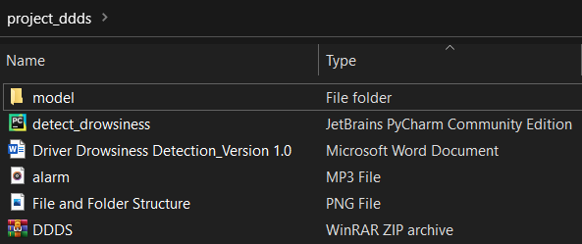

###### Pic 2

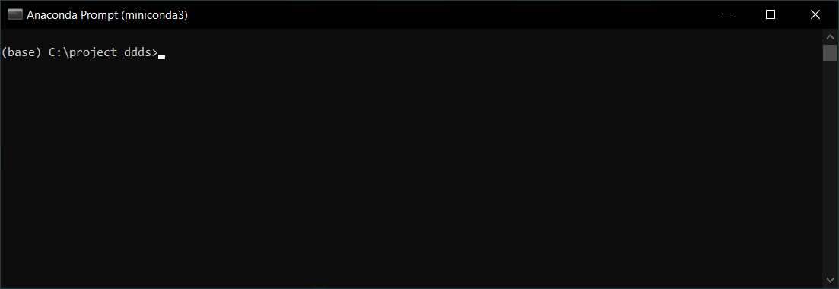

###### Pic 3

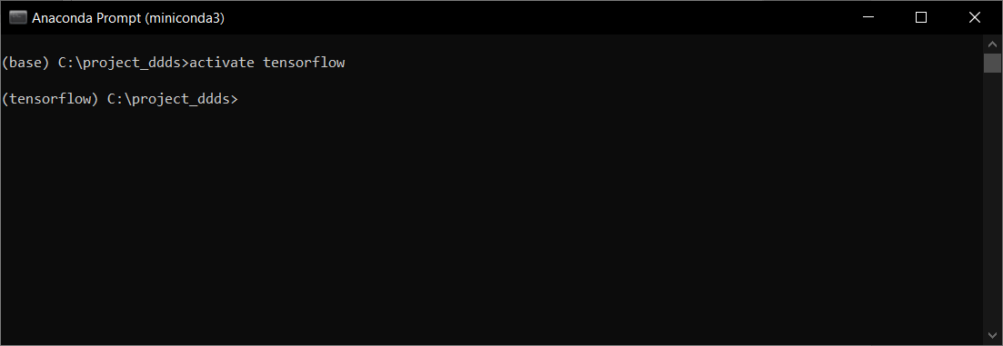

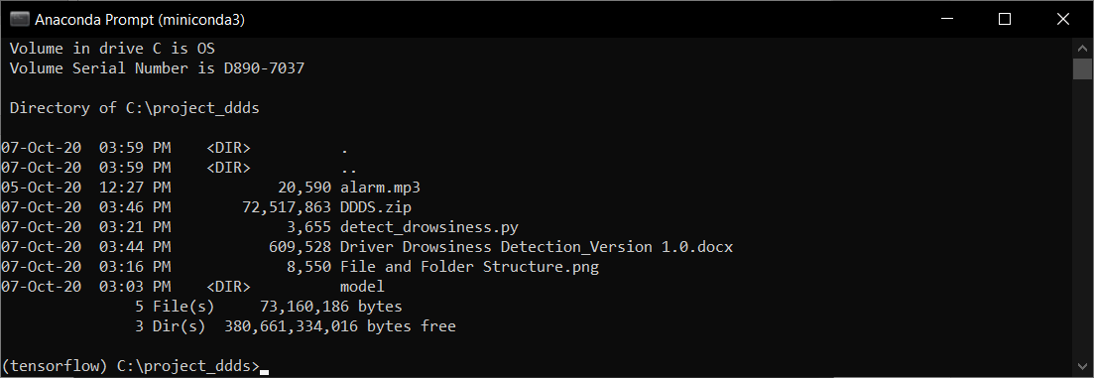

###### Pic 4

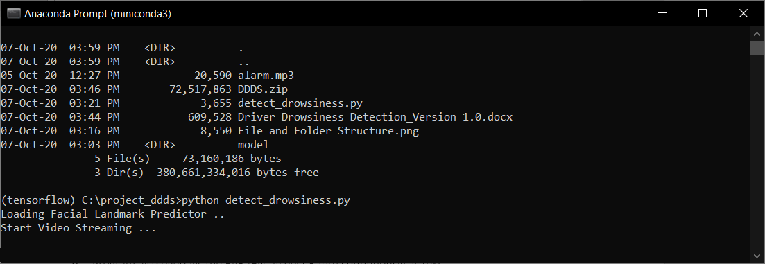

###### Pic 5

###### Pic 6